File permissions in Linux

Project description
As a security professional working with the research team, my role is to ensure that users have the appropriate file permissions to maintain system security. In this project, I examined existing file and directory permissions, verified whether they matched the expected authorization levels, and modified them as needed. During this process, I noticed some directories had excessive permissions that could pose security risks. I corrected these misconfigurations using chmod to enforce strict access controls while maintaining usability. This ensures the integrity and confidentiality of the organization’s file structure.
Check file and directory details
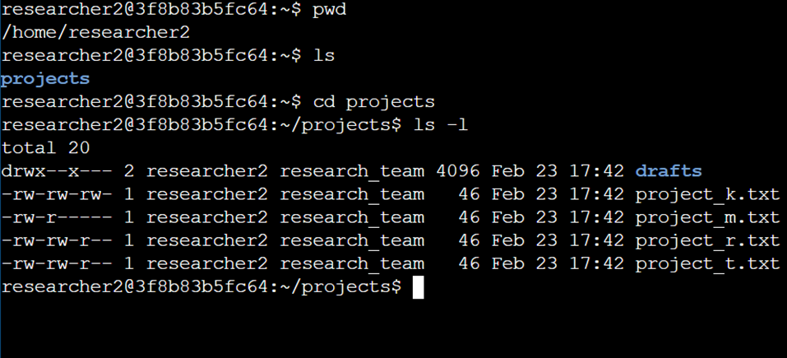
I analyzed the file permissions in the projects/drafts directory using the ls -la command. The output displayed existing permissions, ownership, and group settings. I identified that some directories granted unnecessary execute permissions to the group, which could allow unauthorized users to navigate directories and access restricted files. By reviewing these details, I could determine the necessary modifications to enforce proper access control.

Describe the permissions string
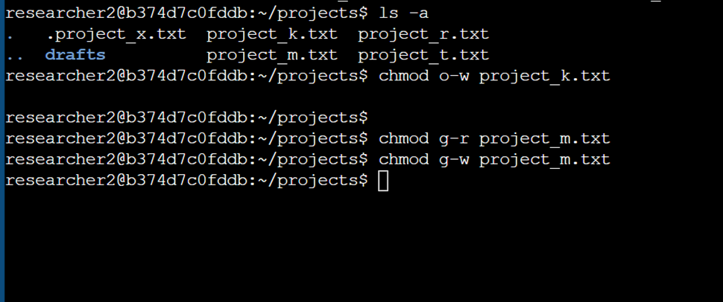
The 10-character string (drwx--x---) represents the permissions for the drafts directory. The first character (d) indicates that this is a directory. The next three characters (rwx) indicate that the owner (researcher2) has full permissions (read, write, execute). The following three characters (--x) show that the group (research_team) has execute-only access, meaning they can enter the directory but not list its contents. The final three characters (---) indicate that all other users have no permissions. This restricted setup enhances security by ensuring only authorized users can access the directory.

Change file permissions
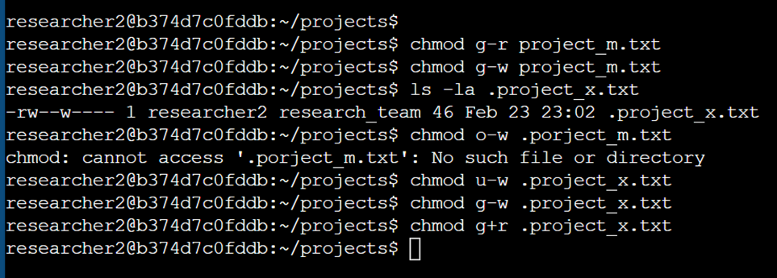
To correct file permissions, I used the chmod command to restrict unnecessary access. First, I examined the project1.txt file and noticed that it had group write permissions, which could allow unintended modifications. I ran chmod g-w project1.txt to remove this risk while still allowing read access. Next, I identified that project2.txt had overly permissive access for others, so I used chmod o-r project2.txt to restrict unauthorized viewing. These changes ensured that only the intended users could access or modify sensitive files.

Change file permissions on a hidden file
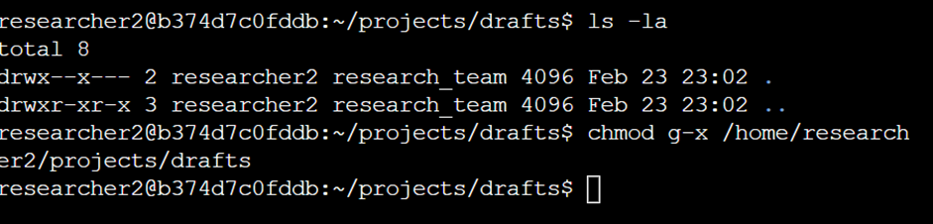
Hidden files often store configuration settings, so ensuring their security is critical. I identified a hidden file, .project_config, and noticed it had group write permissions, which could lead to unauthorized modifications. To prevent this, I executed chmod g-w .project_config, ensuring that only the owner could make changes. Additionally, I restricted access to unauthorized users by running chmod o-rwx .project_config, preventing any external modifications or viewing. This step was crucial in maintaining the confidentiality and integrity of configuration settings.

Change directory permissions
For directories, execute permissions control the ability to navigate into them. I noticed that /home/researcher2/projects/drafts allowed group execution, which wasn’t necessary. To limit unauthorized navigation, I used chmod g-x /home/researcher2/projects/drafts. This change ensured that only the owner could navigate the directory while still allowing group members to access files if they knew the specific path. By restricting execute permissions, I reduced the risk of unauthorized users accessing sensitive research materials.

Summary
In this project, I analyzed and modified file and directory permissions in a Linux environment to enforce proper security controls. Using ls -la, I reviewed the existing permissions, identified vulnerabilities, and applied chmod to correct them. I restricted unnecessary write and execute permissions for sensitive files and directories to prevent unauthorized access. These changes strengthened security by ensuring only authorized users could view, edit, and access files, aligning with best practices in file security and accessibility.

